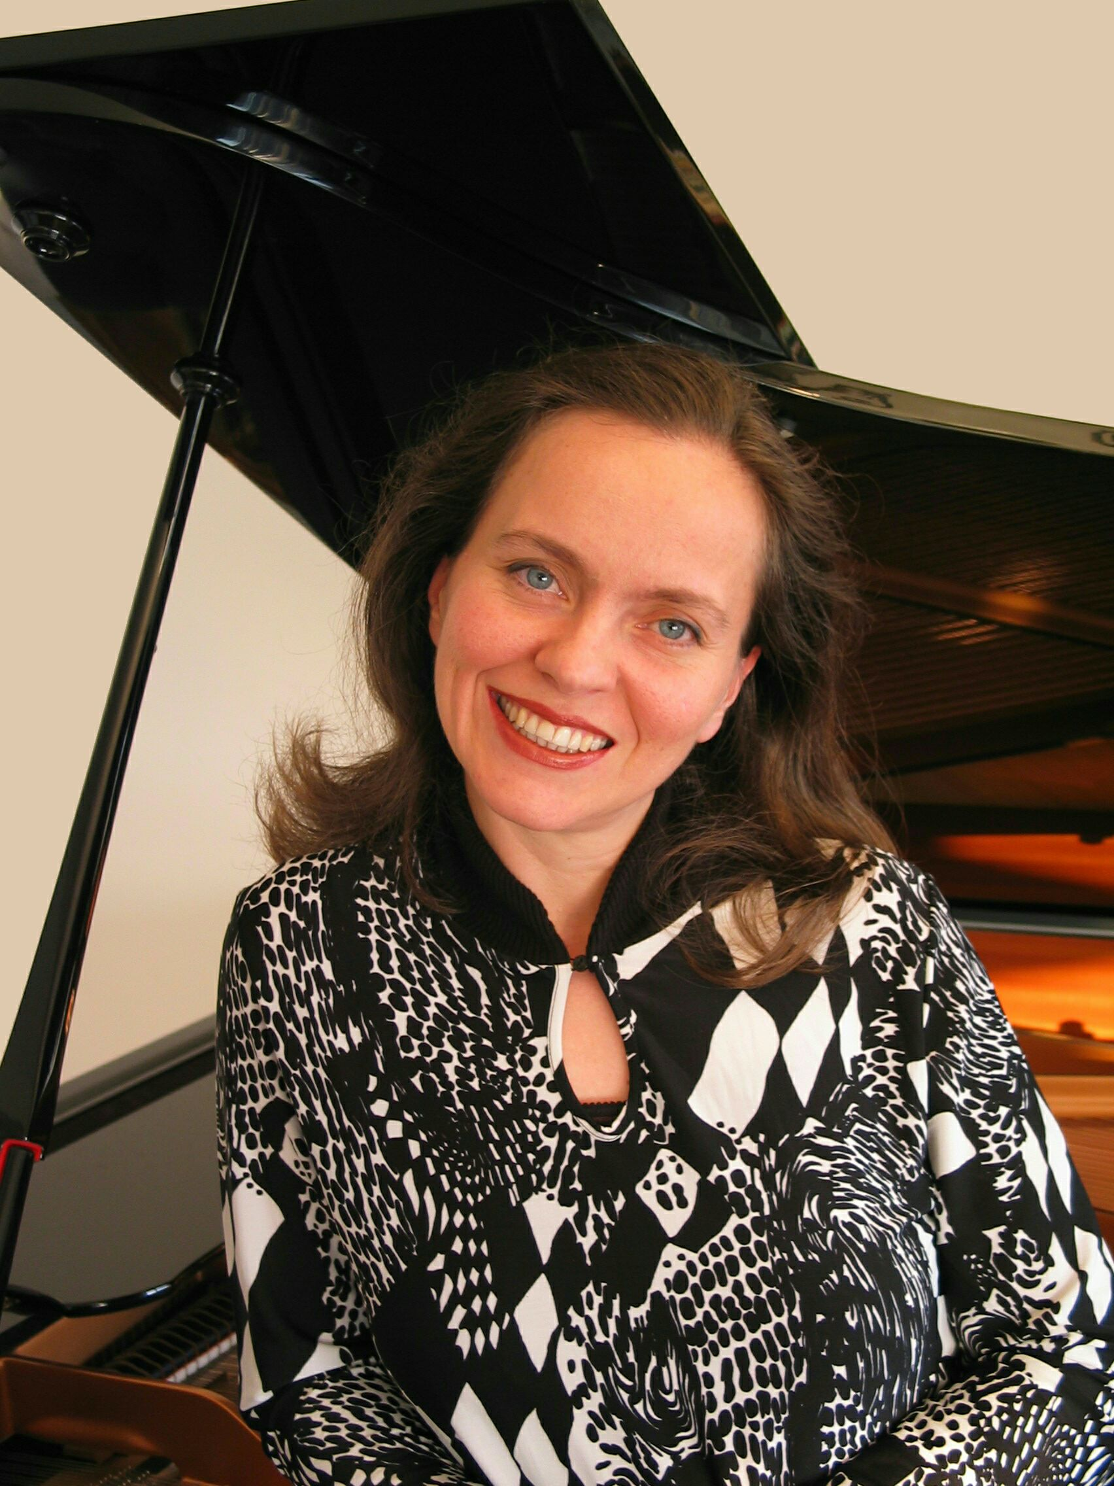

Zeynep Ucbasaran
piano
in recital

Sunday, December 4, 2005
4:00 pm

The Unitarian Society of Santa Barbara
1535 Santa Barbara Street
Santa Barbara, CA 93101
Tel: (805) 965-4583

PROGRAM

Ludwig van Beethoven 11 Bagatelles (Op. 119)
A. Adnan Saygun 12 Preludes on Aksak Rhythms, (Op. 45, No. 2, 6, 8, 9)
Joseph Haydn Sonata in E minor (Hob. XVI/34)
Maurice Ravel Sonatine
Franz Liszt Waldesrauschen
Sunt Lacrymae Rerum
Reminiscences de Lucia di Lammermoor

Co-sponsored by UCSB Music Affiliates and the Santa Barbara Music Club
Special thanks to Mrs. Carnzu Clark and the Unitarian Society of Santa Barbara

Donation requested: $15 general, $10 for students and seniors.

